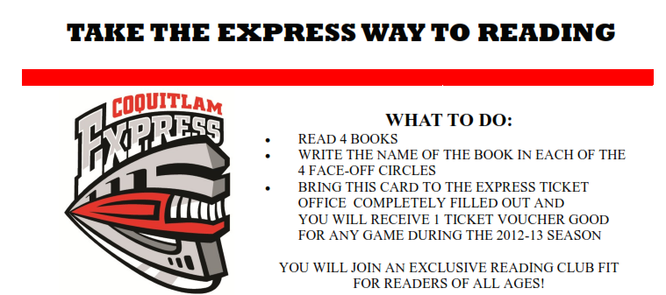
- Read at home 20 days in October, 15 minutes per day. This can be weekdays or weekend days. Complete the log on the reverse.
- Write the titles of four books you read in each of the four face-off circles.
- At the end of October ask your teacher to sign it.
- Bring this sheet to the Express Ticket Office and you will receive one ticket voucher good for any game during the 2012-2013 season.
You will join an exclusive reading club fit for readers of all ages!

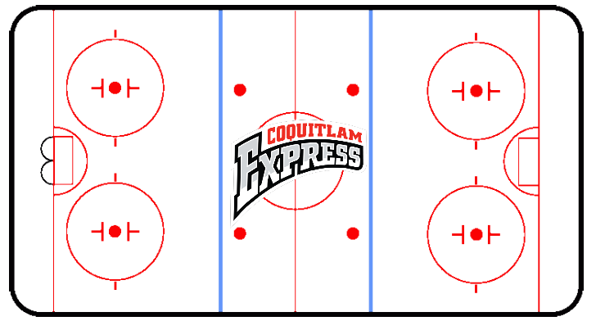
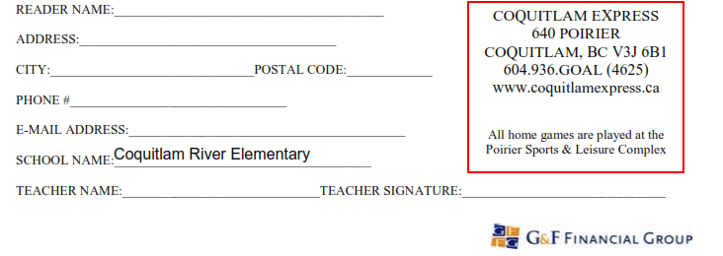

Coquitlam Express Way to Reading!! – October 2012
Complete this chart by reading 20 days in October. Then complete the reverse side, get it signed by your teacher and take it to the Poirier Arena Box Office for a free ticket to any Coquitlam Express home game in the 2012-2013 season!
Date | Title of Book | Parent’s Initials

